Table of Contents

Appendix A 3

1. Login/Logout: 3

2. Main Menu 4

3. Add new stock 5

4. Remove Existing Stock 7

5. Edit Existing Stock 8

6. Search Stock 9

7. Edit Transaction (Special Feature) 10

8. Process Transaction (Stock in) 11

9. Process Transaction (Stock out) 12

10. Daily Stock Summary Report 13

11. Weekly Stock Summary Report 14

12. Monthly Stock Summary Report 15

13. Yearly Stock Summary Report 16

14. Exit 17

Appendix B 18

1. Login/Logout 18

2. Logout 19

3. Main Menu 20

4. Add new stock item 21

5. Remove Existing Stock Item 22

6. Edit Existing Stock Item 23

7. Search Stock Item 24

8. Search Stock Item (Continue Diagram 1.0) 25

9. Process Transaction 26

10. Process Transaction 27

11. Edit Transaction (Special Feature) 28

12. Daily Stock Summary Report 29

13. Weekly Stock Summary Report 30

14. Monthly Stock Summary Report 31

15. Yearly Stock Summary Report 32

16. Exit 33

Appendix C 34

1. Login 34

2. Add new stock item 34

3. Remove Existing stock item 35

4. Edit existing stock item 37

5. Search Item menu 38

5.1. Search Item by ID 39

5.2. Search Item by Name 40

5.3. Search Item by Category 40

5.4. Search Item by Price 41

5.5. Search Item by Quantity 42

6. Process Transaction Menu 43

6.1. Process Transaction In 44

6.2. Process Transaction Out 45

7. Edit Transaction 46

8. View Summary 47

Appendix D 48

1. Login 48

2. Add new stock item 49

3. Remove Existing stock item 50

4. Edit Existing Stock 51

5. Search Item Menu 52

5.1. Search Item by ID 53

5.2. Search Item by Name 54

5.3. Search Item by Category 55

5.4. Search Item by Price 56

5.5. Search Item by Quantity 57

6. Process Transaction Menu 58

6.1. Process Transaction Menu 59

6.2. Process Transaction Menu 60

7. Edit Transaction 61

8. View Summary 62

Appendix E 63

1. Log in 63

2. Add new stock 64

3. Remove stock 65

4. Edit existing stock item 66

5. Search stock item 68

5.1. Search item by ID 69

5.2. Search item by name 70

5.3. Search item by category 71

5.4. Search item by price 72

5.5. Search item by quantity 73

6. Process Transaction 74

6.1. Process incoming stock 75

6.2. Process outgoing stock 75

7. Edit transaction 77

8.1. View daily stock summary report 78

8.2. View weekly summary report 79

8.3. View monthly summary report 80

8.4. View yearly stock summary report 81

# 

# Appendix A

## 1. Login/Logout:

Click on “Logout”

Enter User ID and Password

Wrong User ID and/or password

Display “Logout Successful”

Read User ID and password

no

Is both correct?

yes

Password unsuccessfully entered 3 times or more?

yes

Marked as “Locked”

no

Store User ID and Password

Display “Login Successful”

Display Main Menu

## 2. Main Menu

Hit “enter”

Read “choice” input

Display Wrong choice input

Is choice 1,2,3,4,5,6,7,8,9,10, 11?

Display “press enter to continue”

no

yes

Add new Stock Item

Case 1

Case 2

Remove Stock Item

Case 3

Edit Stock Item

Case 4

Search Stock Item

Case 5

Edit Transaction

Process Transaction

Case 6

Case 7

Daily Stock Summary

Weekly Stock Summary

Case 8

Case 9

Monthly Stock Summary

Case 10

Yearly Stock Summary

Case 11

Exit

## 3. Add new stock

Enter Item name, item category, item sub-category

Error message, “Item already existed!”

Item exists?

yes

no

Generate Item ID

Read Item Details

Save new Item

Display “Added successfully”

## 4. Remove Existing Stock

Enter item ID

Error message, “Item not existed!”

Read Item ID

no

Item exists?

yes

Display item details

no

Proceed to delete?

yes

Delete Item

Display “Removed successfully”

## 5. Edit Existing Stock

yes

no

Error message, “Item not existed!”

Item exists?

Enter Item ID

Read Item ID

Display item details

no

Proceed to edit?

yes

Read updated Stock Detail

Enter Stock Detail

Save Update

Display “Update Successful”

## 6. Search Stock

Read “selection” input

Error message, “Item not existed!”

Read Item ID and/or Description

Display Wrong choice input

no

Is choice A,B,C,D,E?

Item exists?

no

yes

yes

Case A

Item Name

Display item of that Stock ID and/or Description

Case B

Category

Case C

Sub-Category

Case D

Price

Case E

Quantity

## 7. Edit Transaction (Special Feature)

Enter Item ID

Error message, “Item not existed!”

Read Item ID

Item Exists?

**no**

yes

Display item transaction details

Proceed to edit?

**no**

**no**

yes

Confirm???

Enter item date, time and/or quantity

yes

Save Update

Read item date, time and/or quantity

## 8. Process Transaction (Stock in)

Stock IN

Enter Item ID

Error message, “Item not existed!”

Read Item ID

Item exists?

no

Enter Item’s Date and Time

yes

Enter Stock number

Is Date and time correct?

Is it valid num and num > 0?

no

no

yes

yes

Create new Transaction

Update Item

Display “successfully Process Item”

## 9. Process Transaction (Stock out)

Stock OUT

Enter Item ID

Error message, “Item not existed!”

Read Item ID

Item exists?

no

Enter Item’s Date and Time

yes

Enter Stock number

Is Date and time correct?

Is it valid num and num > 0?

no

yes

Create new Transaction

Update Item

Display “successfully Process Item”

## 10. Daily Stock Summary Report

Display a daily list of Items in summary

Export full report in text file?

no

yes

Export

Display “Export Successful”

## 11. Weekly Stock Summary Report

Display a weekly list of Items in summary

Export full report in text file?

**no**

yes

Export

Display “Export Successful”

## 12. Monthly Stock Summary Report

Display a monthly list of Items in summary

Export full report in text file?

**no**

yes

Export

Display “Export Successful”

## 13. Yearly Stock Summary Report

Display a yearly list of Items in summary

Export full report in text file?

**no**

yes

Export

Display “Export Successful”

## 14. Exit

Exit System

Clear the program

Hit on “Enter”

# Appendix B

## 1. Login/Logout

Enter User ID and Password

Read User ID and password

no

Is both correct?

Decline Login

Password unsuccessfully entered 3 times or more?

yes

Display “Login Successful”

no

Display Main Menu

yes

Marked as “Locked”

Display “Account Locked”

## 2. Logout

Click on “Logout”

Display “Logout Successful”

## 3. Main Menu

Hit “enter”

Read “choice” input

Display Wrong choice input

Is choice 1,2,3,4,5,6,7,8,9,10, 11?

Display “press enter to continue”

no

yes

Add new Stock Item

Case 1

Case 2

Remove Stock Item

Case 3

Edit Stock Item

Case 4

Search Stock Item

Case 5

Process Transaction

Edit Transaction

Case 6

Case 7

Daily Stock Summary

Weekly Stock Summary

Case 8

Case 9

Monthly Stock Summary

Case 10

Yearly Stock Summary

Case 11

Exit

## 4. Add new stock item

Enter Item name, item category, item sub-category

Error message, “Item already exists!”

Item exists?

no

Generate Item ID

Enter Item and Transaction Details

yes

User input == “quit”?

no

Add another item?

Read Item and Transaction Details

no

Save new Item

yes

Display “Added successfully”

## 5. Remove Existing Stock Item

Enter item ID

Read Item ID

no

Error message, “Item does not exist!”

Item exists?

yes

Display item details

no

Proceed to delete?

yes

Remove another item?

Delete Item

no

Display “Removed successfully”

yes

## 6. Edit Existing Stock Item

yes

no

Item exists?

Enter Item ID

Read Item ID

Error message, “Item does not exist!”

Display item details

no

Proceed to edit?

yes

Read updated Stock Detail

Enter Stock Detail

Save Update

Display “Update Successful”

## 7. Search Stock Item

Read “selection” input

Display Wrong choice input

no

Is choice A,B,C,D,E?

yes

Case A

Item ID

Item Name

Case B

Enter Input

Case C

Category

Read Input

Case D

Price

Case E

Display search results

Quantity

Case F

Exit

## 8. Search Stock Item (Continue Diagram 1.0)

Enter Item ID

Read ID

Display error message “Item does not exists”

no

Item exists?

yes

Is history > 2 months || history > 100 records

Display search results

no

Display all history

Display transaction history”?

yes

yes

Display history up to 2 months, under 100 records

no

Export full transaction history?

no

yes

Export transaction history

## 9. Process Transaction

Stock IN

Enter Item ID

Error message, “Item does not exist!”

Read Item ID

Item exists?

yes

no

User input == “quit”?

Enter Transaction’s Date and Time

yes

no

Enter Stock quantity

Is Date and time Valid?

User input == “quit”?

no

yes

Is it valid num and num > 0?

Create new Transaction

Update Item

Display “successfully Process Item”

no

yes

## 10. Process Transaction

Stock IN

Enter Item ID

Error message, “Item does not exist!”

Read Item ID

Item exists?

yes

no

Enter Transaction’s Date and Time

User input == “quit”?

yes

no

Enter Stock quantity

Is Date and time Valid?

User input == “quit”?

no

yes

Is it valid num and num > 0?

Create new Transaction

Update Item

Display “successfully Process Item”

no

yes

## 11. Edit Transaction (Special Feature)

Enter transaction ID

Read transaction ID

Transaction Exists?

Error message, “Transaction does not exist!”

**no**

yes

Display item transaction details

Proceed to edit?

**no**

**no**

yes

User input == “quit”?

Confirm details?

yes

Enter details

Save Update

Read details

## 12. Daily Stock Summary Report

Display a daily list of Items in summary

Export full report in text file?

no

yes

Export

Display “Export Successful”

## 13. Weekly Stock Summary Report

Display a weekly list of Items in summary

Export full report in text file?

**no**

yes

Export

Display “Export Successful”

## 14. Monthly Stock Summary Report

Display a monthly list of Items in summary

Export full report in text file?

**no**

yes

Export

Display “Export Successful”

## 15. Yearly Stock Summary Report

Display a yearly list of Items in summary

Export full report in text file?

**no**

yes

Export

Display “Export Successful”

## 16. Exit

Exit System

Clear the program

Hit on “Enter”

# Appendix C

## 1. Login

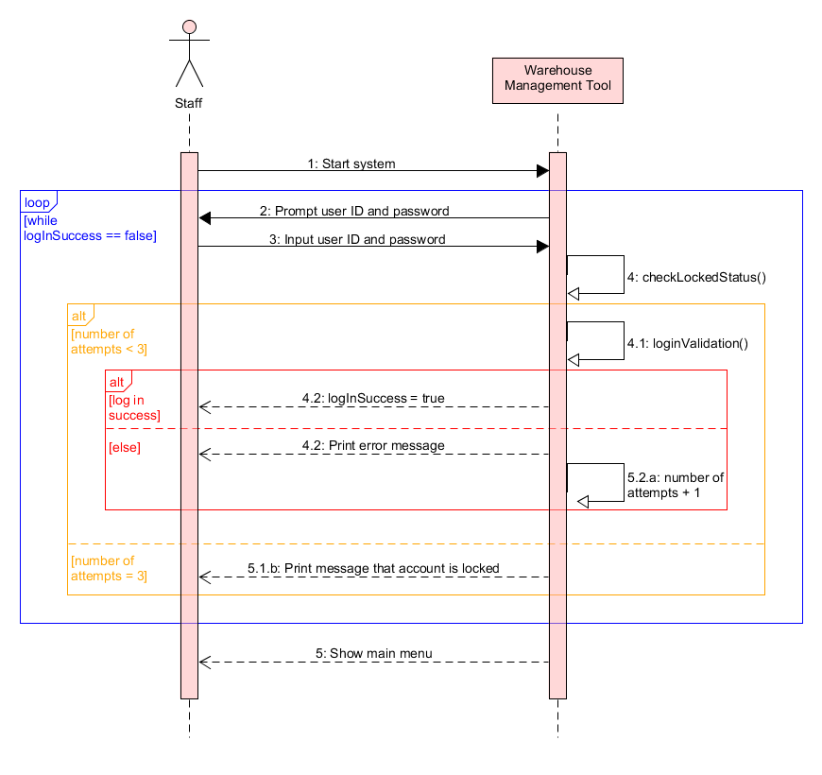

## 2. Add new stock item

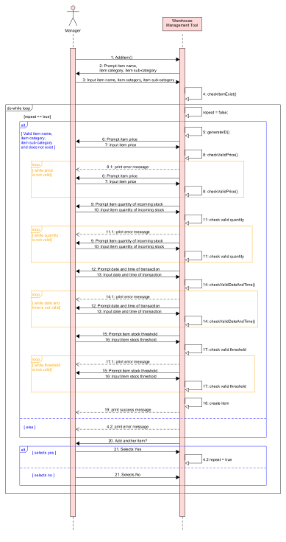

## 3. Remove Existing stock item

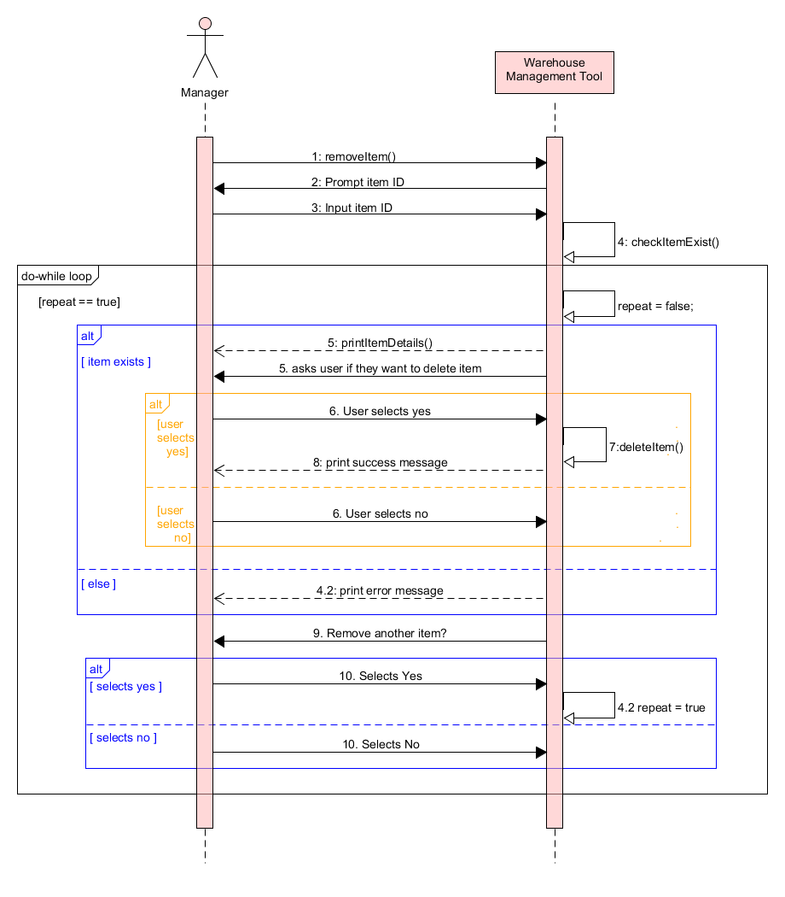

## 4. Edit existing stock item

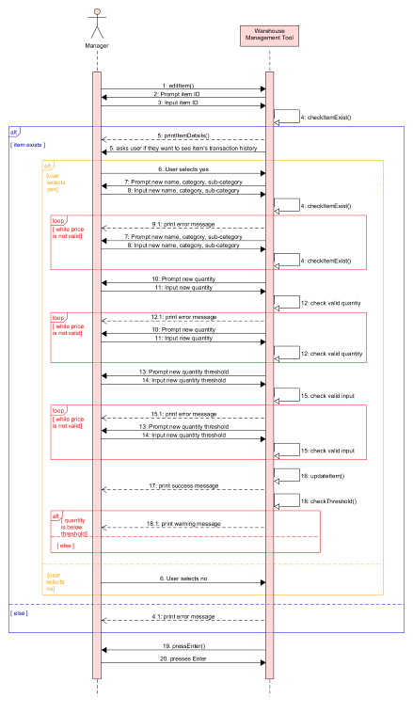

## 5. Search Item menu

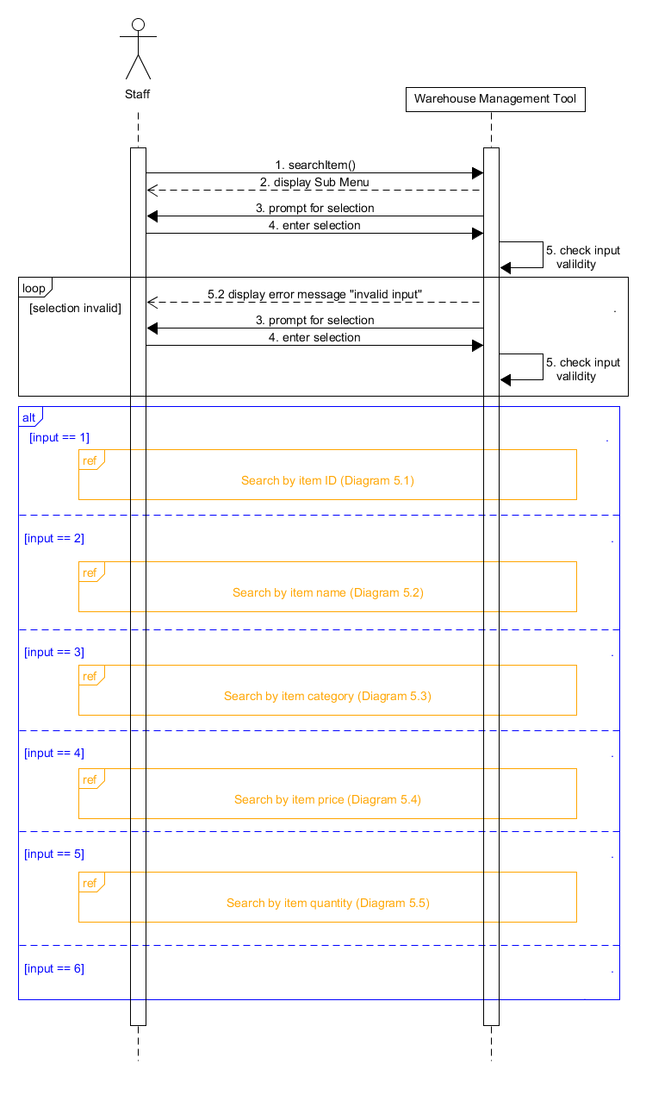

### 5.1. Search Item by ID

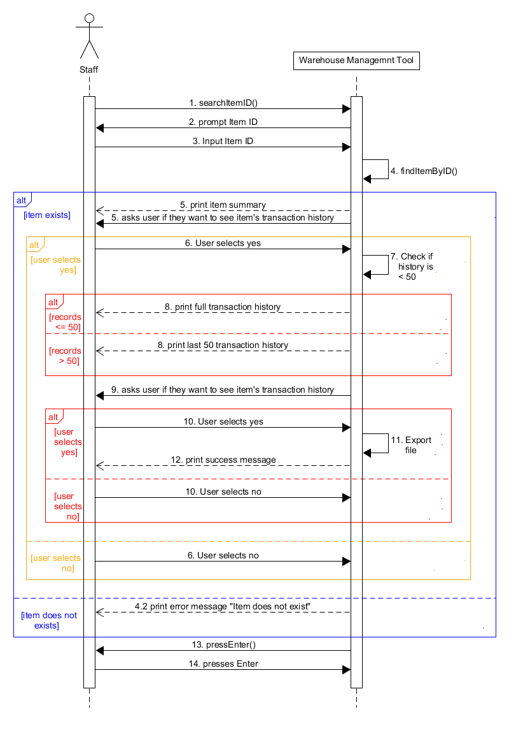

### 5.2. Search Item by Name

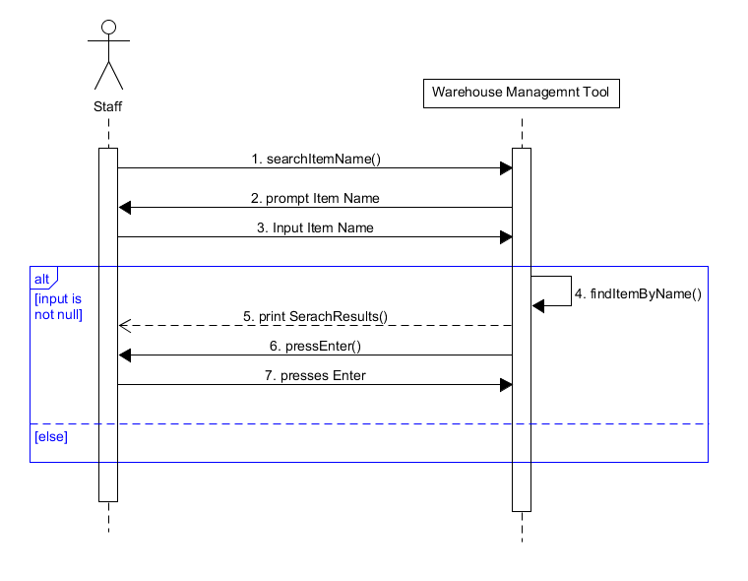

### 5.3. Search Item by Category

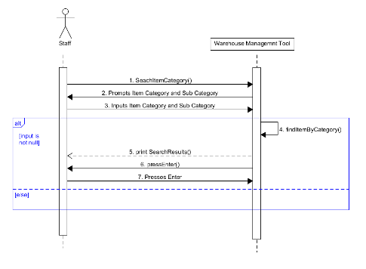

### 5.4. Search Item by Price

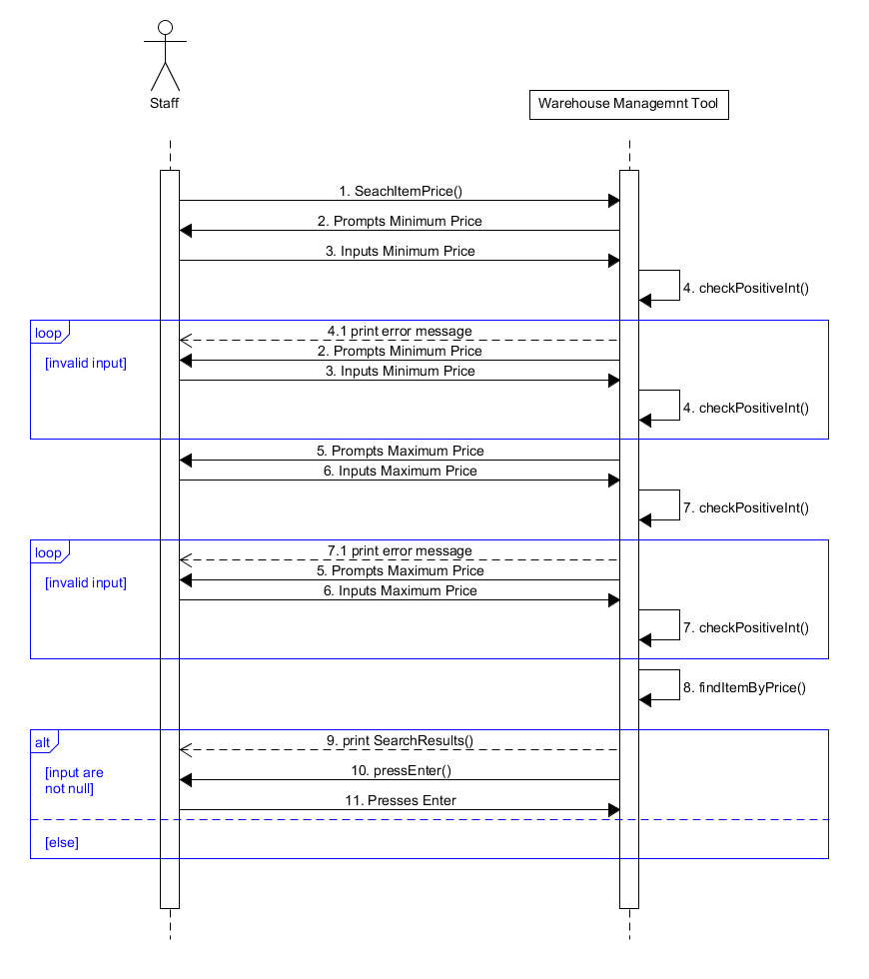

### 5.5. Search Item by Quantity

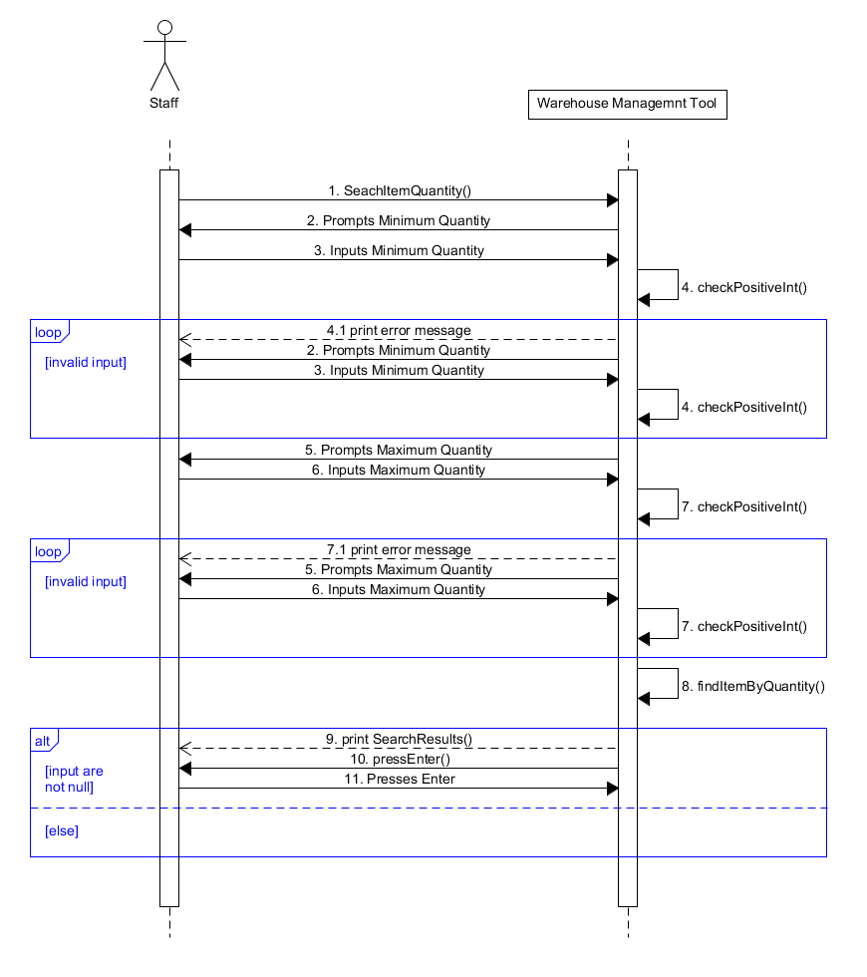

## 6. Process Transaction Menu

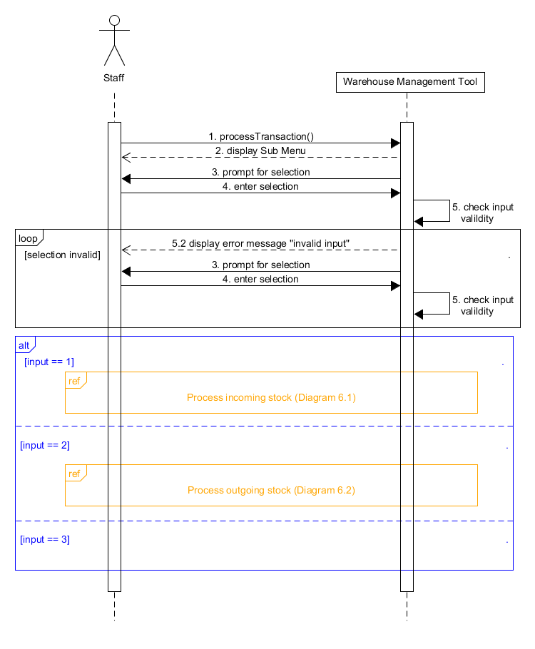

### 6.1. Process Transaction In

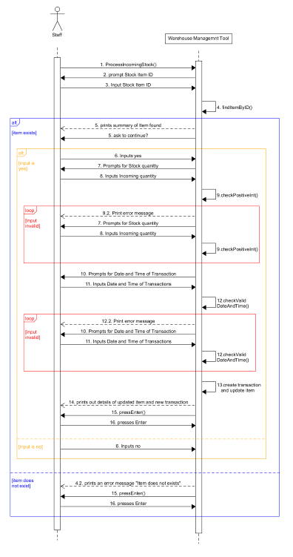

### 6.2. Process Transaction Out

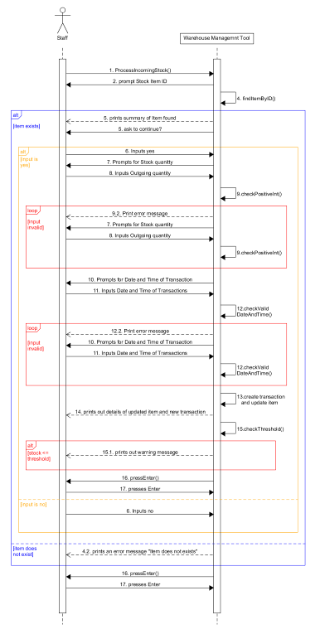

## 7. Edit Transaction

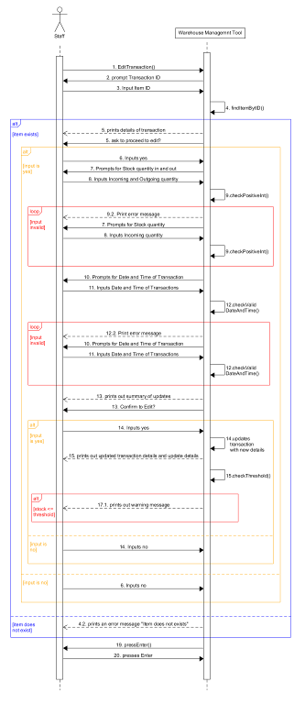

## 8. View Summary

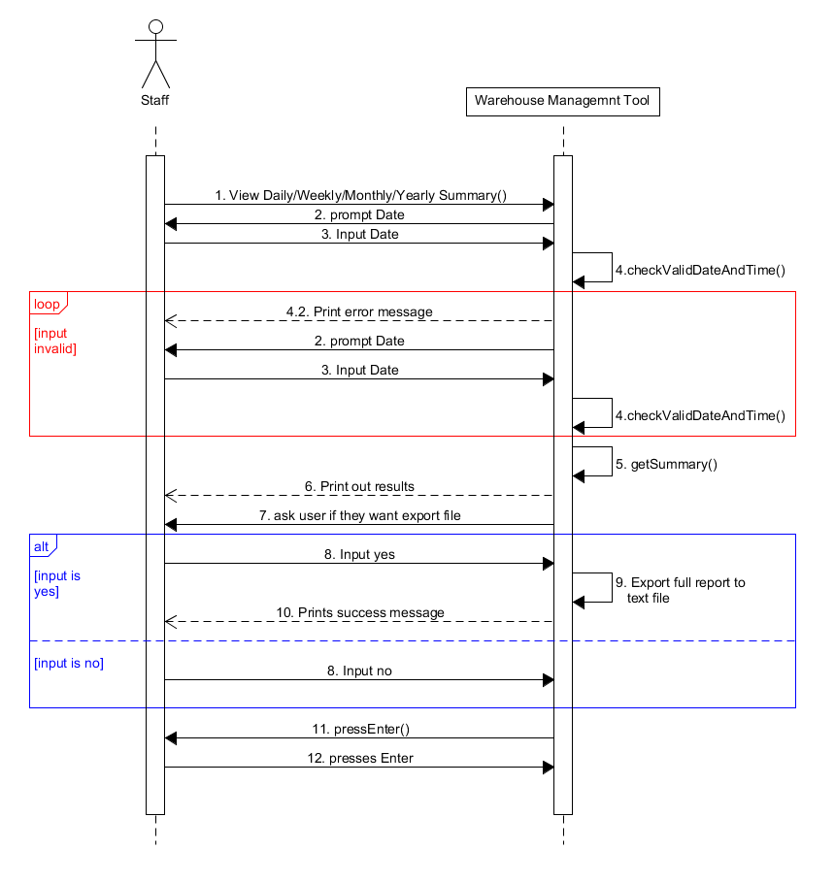

# Appendix D

## 1. Login

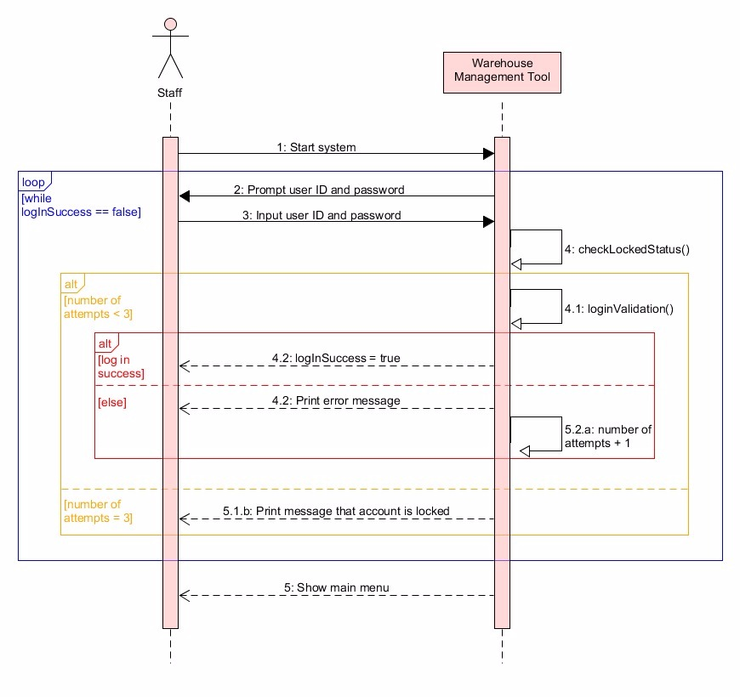

## 2. Add new stock item

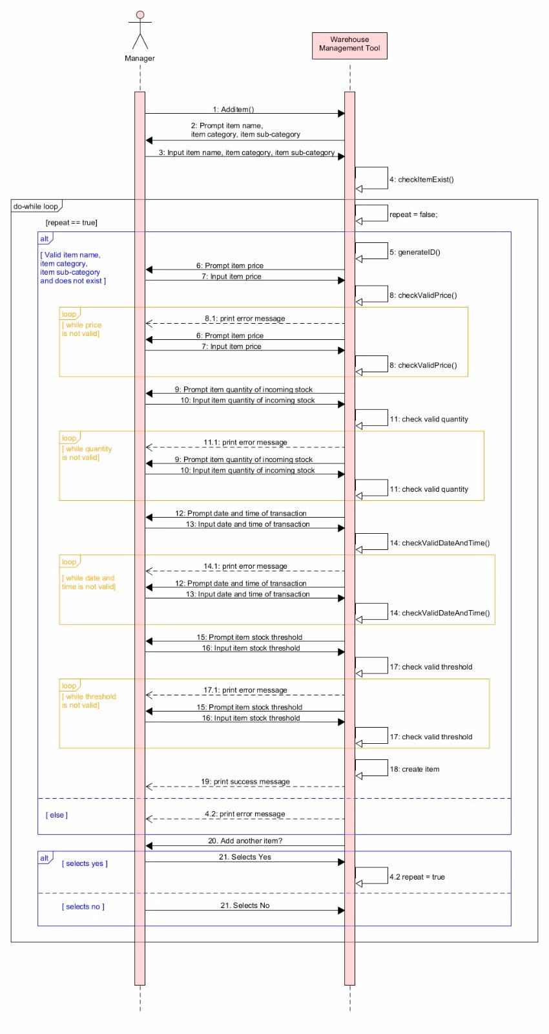

## 3. Remove Existing stock item

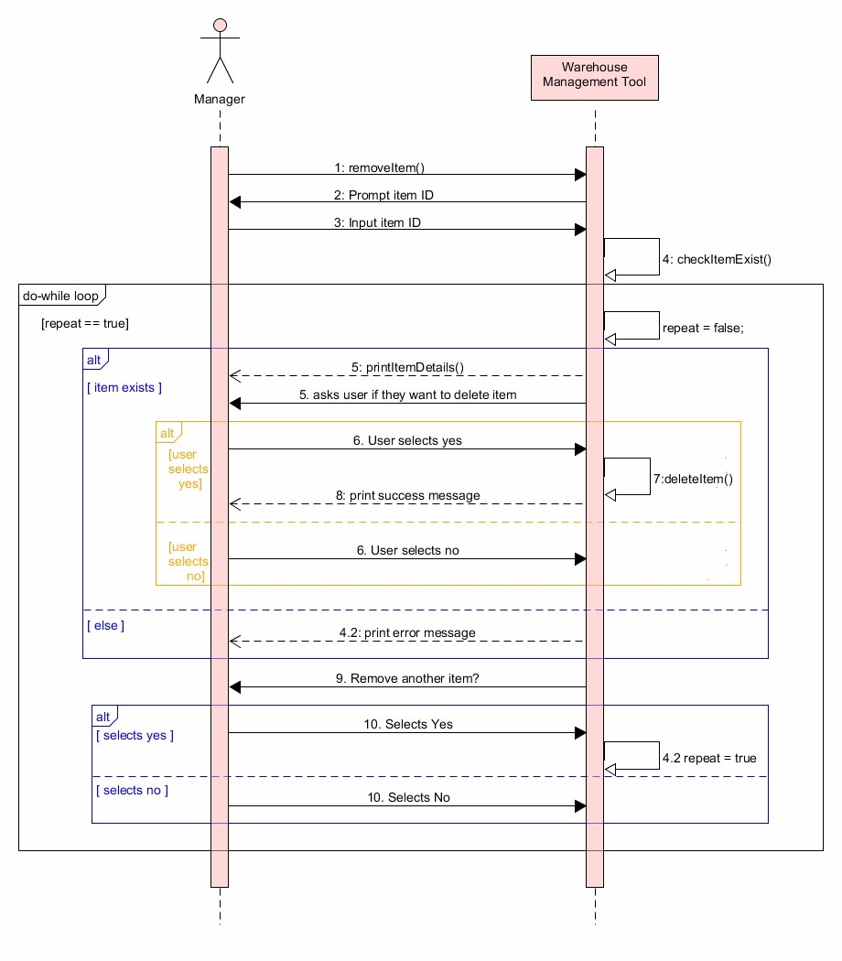

## 4. Edit Existing Stock

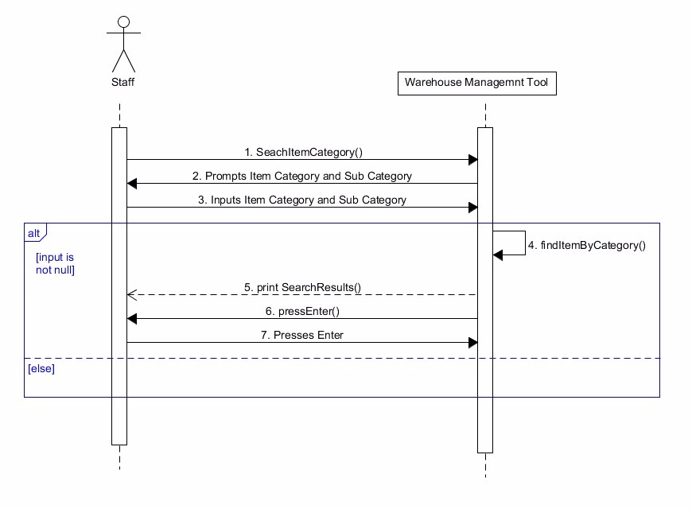

## 5. Search Item Menu

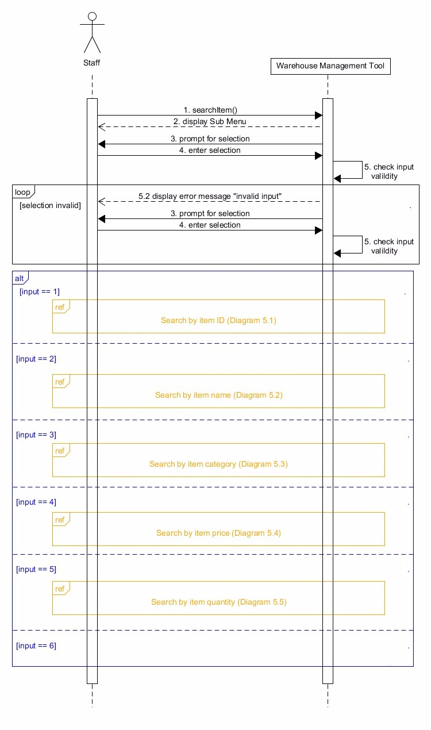

## 5.1. Search Item by ID

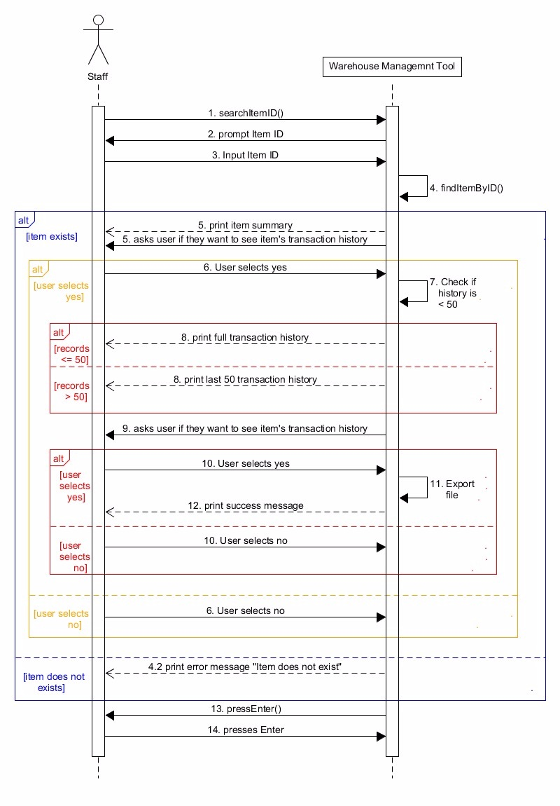

## 5.2. Search Item by Name

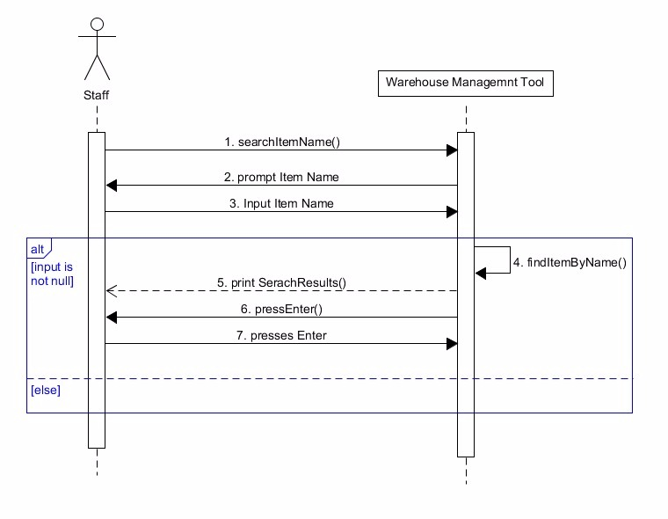

## 5.3. Search Item by Category



## 5.4. Search Item by Price

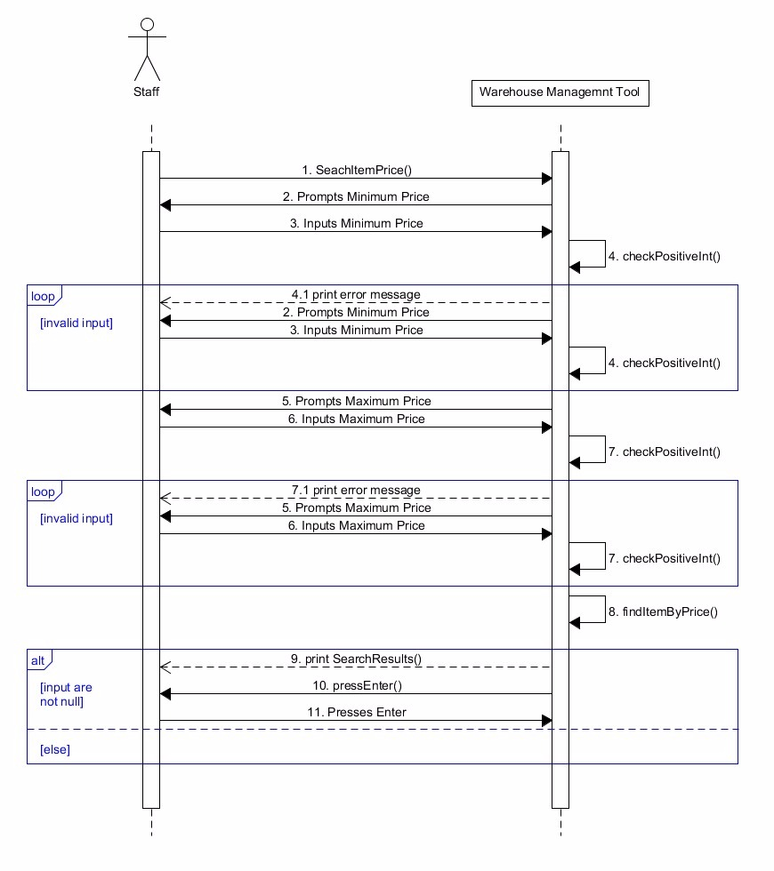

## 5.5. Search Item by Quantity

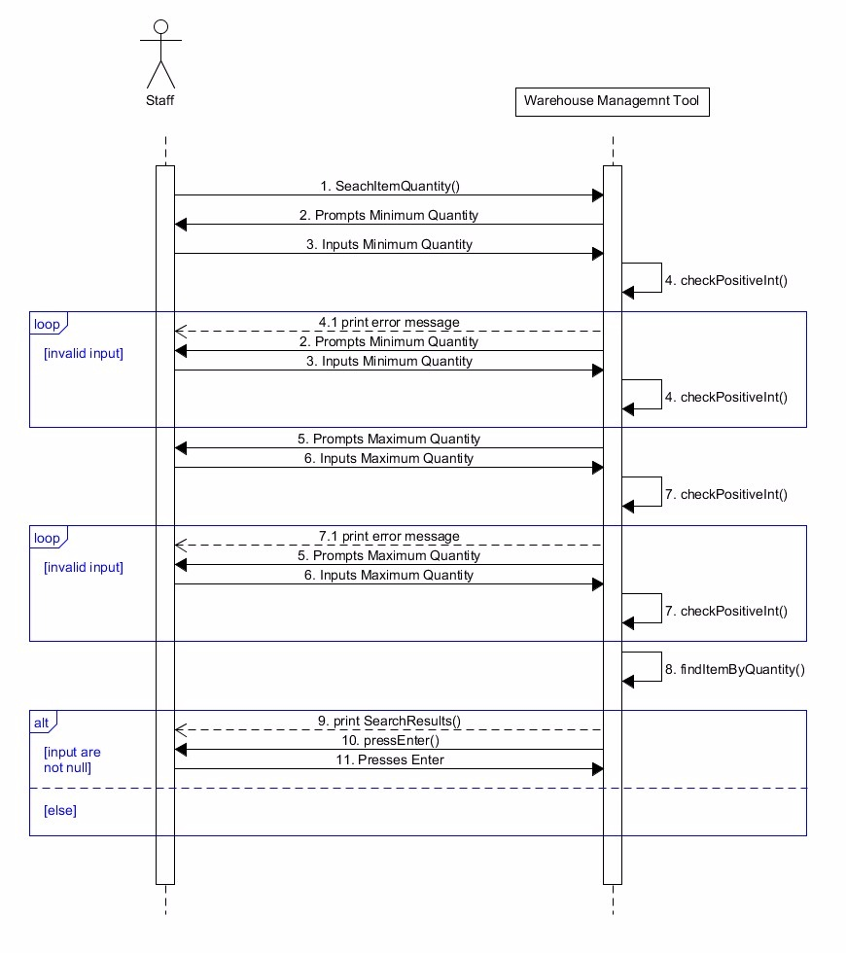

## 6. Process Transaction Menu

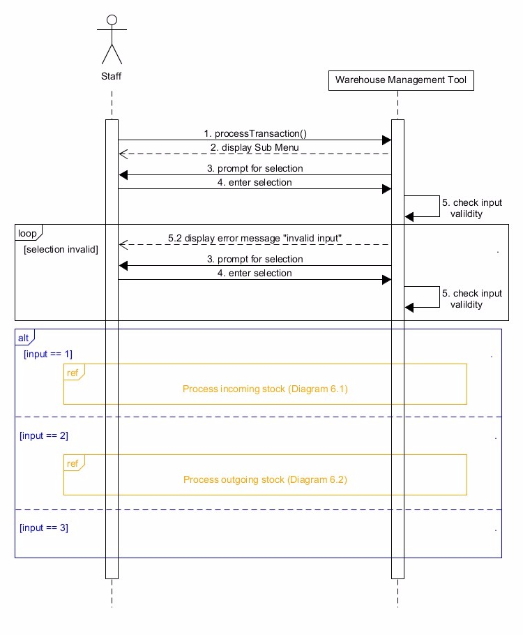

## 6.1. Process Transaction Menu

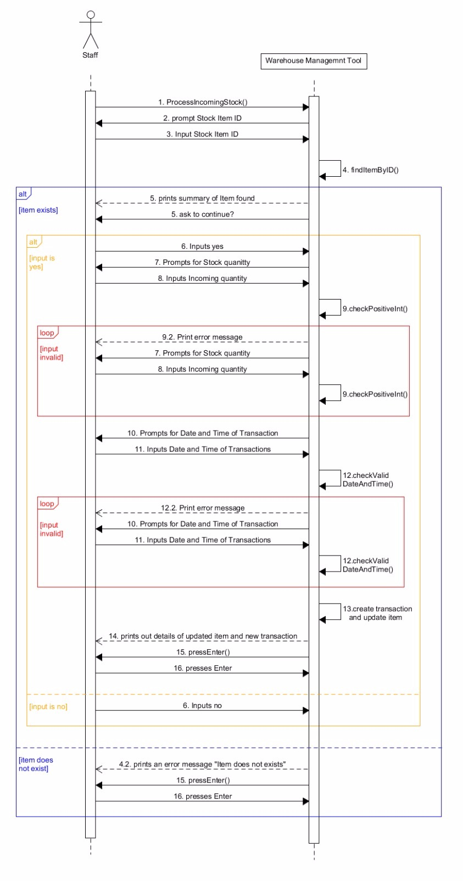

## 6.2. Process Transaction Menu

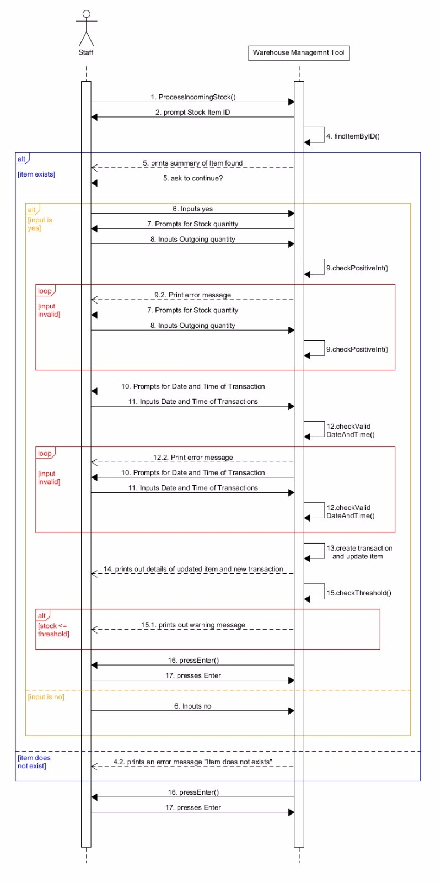

## 7. Edit Transaction

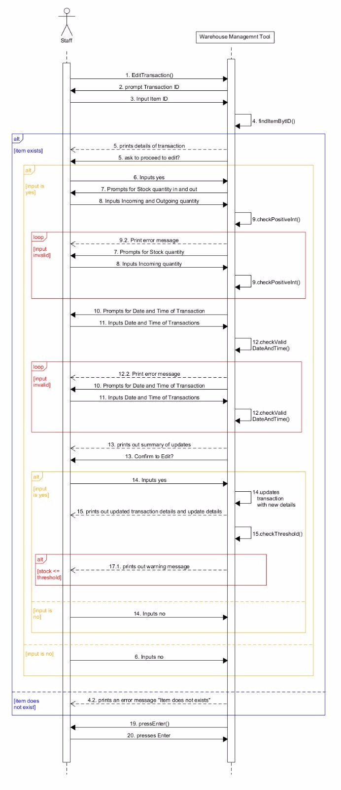

## 8. View Summary

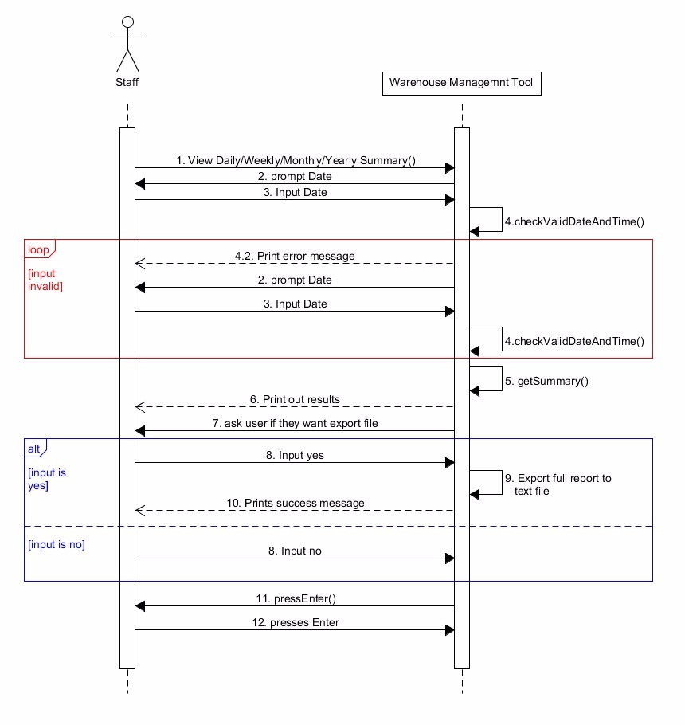

# Appendix E

## 1. Log in

|  |  |
| --- | --- |
| **Use Case Textual Description** | |
| **UC-ID** | 1. |
| **Name** | Login |
| **Description** | Staff or Manager logging into Warehouse Management Tool system to use the program. |
| **Actor(s)** | Both Staff and Manager have the right to log in to this system. |
| **Main Scenario** | 1. User turns on system  2. System prompts for user ID and password  3. User keys in user ID and password  4. System checks if user account is locked  5. System checks if user ID and password input is correct  6. Upon match, System logs user in |
| **Possible Scenario** | **Wrong user name and password**  A – 5.1.a. Upon mismatch, system shows error message and re-prompts user to input user ID and password again.  A – 5.2.a. System updates user ID’s number of attempts at logging in by incrementing 1.  **3rd failed attempt at logging in**  B – 5.1.b. Upon mismatch on 3rd attempt, system shows error message to user and tells user that they are locked out from logging in.  B – 5.2.a. System updates user ID’s number of attempts at logging in by incrementing 1.  **Attempting to log in when locked out**  C – 4.1. System notices that user has attempted to log in 3 times.  C – 4.2. System shows error message to user saying that they are no longer allowed to log in. |

## 2. Add new stock

|  |  |
| --- | --- |
| **Use Case Textual Description** | |
| **UC-ID** | 2. |
| **Name** | Add new stock item |
| **Description** | Manager will add a new stock and enter all details into the system. |
| **Actor(s)** | Manager is the only person who has the right to add a new stock. |
| **Main Scenario** | 1. Manager selects “Add new stock item” from main menu  2. System prompts to enter item name, category, and sub category  3. Manager enter above details for new item.  4. System checks if item already exists  5. System fetches last item ID and generates ID for new item.  6. System prompts for item price.  7. Manager enters item price.  8. System checks if input is valid.  9. System prompts for quantity of incoming stock.  10. Manager enters incoming stock quantity.  11. System checks if input is valid.  12. System prompts for date and time of transaction.  13. Manager enters date and time of transaction  14. System checks if input is valid.  15. System prompts for item stock threshold.  16. Manager inputs item stock threshold.  17. System checks if input is valid.  18. System creates item and transaction with gathered input.  19. System prints success message and details of newly created item.  20. System asks user if they would like to add another item  21. Manager selects No.  24. System ends process and returns to previous menu |
| **Possible Scenario** | **Stock already exists**  A – 4.1. System found that item already exists.  A – 4.2. System prints error message and returns to main menu.  **Input value is wrong**  B – 8.1. / 11.1 / 14.1 / 17.1 System finds invalid input.  B – 8.2. / 11.2 / 14.2 / 17.2 System prints error message and prompt for correct input.  **Manager wants to add another item**  C – 21. Manager selects Yes  C – 21.2. System repeats process from step 2. |

## 3. Remove stock

|  |  |
| --- | --- |
| **Use Case Textual Description** | |
| **UC-ID** | 3. |
| **Name** | Remove stock |
| **Description** | Manager will remove all details of an existing stock from the system. |
| **Actor(s)** | Manager is the only person who has the right to remove an existing stock. |
| **Main Scenario** | 1. Manager selects “Remove existing stock” from main menu  2. System prompts for item ID.  3. Manager enter item ID.  4. System checks for item with given ID  5. System print out the item details and ask the manager if they want to proceed to delete.  6. Manager select Yes.  7. System deletes item from data.  8. System prints success message  9. System asks Manager if they would like to remove another item  10. Manager selects No  11. System ends process and returns to previous menu |
| **Possible Scenario** | **Item does not exist**  A – 4.1. System cannot find item with given ID.  A – 4.2. System prints error message, and returns to main menu.  **Manager changes their mind**  B – 6. Manager selects No.  B – 6.1. System returns to main menu.  **Manager wants to add another item**  C – 10. Manager selects Yes  C – 10.2. System repeats process from step 2. |

## 4. Edit existing stock item

|  |  |
| --- | --- |
| **Use Case Textual Description** | |
| **UC-ID** | 4. |
| **Name** | Edit existing stock item |
| **Description** | Manager edit the existing stock item. |
| **Actor(s)** | Manager is the only person who has the right to edit an existing stock item. |
| **Main Scenario** | 1. Manager selects “Edit existing stock item” from main menu.  2. System prompts user to enter item ID  3. Manager enter item ID of an item that they want to edit.  4. System checks for item with given ID  5. System displays the details of this stock item and asks Manager if they want to proceed to edit  6. Manager selects Yes.  7. System prompts for item’s new name, category, sub-category.  8. Manager inputs all required information mentioned above.  9. System checks if input entered clashes with any existing data.  10. System prompts for new quantity.  11. Manager inputs quantity value.  12. System checks if input is valid.  13. System prompts for new quantity threshold.  14. Manager inputs new quantity threshold.  15. System checks if input is valid  16. System updates item with new information  17. System prints item description with new information  18. System checks if item quantity is below threshold  19. System tells user to press enter to continue  20. User presses enter  21. System ends process and returns to previous menu |
| **Possible Scenario** | **Stock item does not exist**  A – 4.1. System could not find item of given ID  A – 4.2. System prints error message and returns to main menu.  **Manager changes mind**  B – 6. Manager selects No.  B – 6.1. System returns to main menu.  **New description clashes with existing item**  C – 9.1. System found existing item with clashing data  C – 9.2. System prints error message and returns to main menu.  **Input value is wrong**  D – 12.1. / 15.1. System finds invalid input.  D – 12.2. / 15.2. System prints error message and prompt for correct input.  **Alert of threshold**  E – 18.1. If the new quantity is below threshold, system prints an alert message. |

## 5. Search stock item

|  |  |
| --- | --- |
| **Use Case Textual Description** | |
| **UC-ID** | 5. |
| **Name** | Search stock item |
| **Description** | Staff and Manager search for stock item and view the details of it. |
| **Actor(s)** | Both Staff and Manager have the right to search for a stock item. |
| **Main Scenario** | 1. User selects “search stock item” from main menu  2. System display the sub-menu for user to select:  Search by item ID. (UID 5.1)  Search by item name. (UID 5.2)  Search by category. (UID 5.3)  Search by price. (UID 5.4)  Search by quantity. (UID 5.5)  Return to main menu  3. System prompts for selection  4. User selects an option.  5. System checks if user input is valid  6. System will bring user to the following corresponding step (see labeled UID) |
| **Possible Scenario** | **Input is invalid**  A – 5.1. System finds user input is invalid or out of range.  A – 5.2. System prints error message and asks user for input again. |

### 5.1. Search item by ID

|  |  |
| --- | --- |
| **Use Case Textual Description** | |
| **UC-ID** | 5.1. |
| **Name** | Search item by ID |
| **Description** | Staff and Manager search for a specific stock item and view the details of it, and also has the option to view item’s transaction history |
| **Actor(s)** | Both Staff and Manager have the right to search for a stock item. |
| **Main Scenario** | 1. User selects “Search by item ID” from previous menu  2. System prompts for item ID  3. User inputs item ID  4. System checks if item with given ID exists  5. System prints out found item’s details, and asks user if they want to view item’s transaction history  6. User selects Yes  7. System checks if transaction history has under 50 records.  8. System prints out full transaction history.  9. System asks if user would like to export full transaction history  10. User selects Yes.  11. System exports full transaction history into text file with appropriate naming convention.  12. System prints success message  13. System tells user to press enter to continue  14. User presses enter  15. System ends process and returns to previous menu |
| **Possible Scenario** | **Item does not exist**  A – 4.1. System cannot find item with given ID.  A – 4.2. System prints error message and returns to previous menu.  **User does not want to see transaction history**  B – 6. User selects No  B – 6.1. System ends process and returns to previous menu  **Transaction history is too long**  C – 7.1. System finds that transaction history is too many (does not fit condition)  C – 8. System prints out only the latest 50 transaction records.  **User does not want to export transaction history**  D – 10. User selects No.  D – 10.1 System ends process returns to previous menu. |

### 5.2. Search item by name

|  |  |
| --- | --- |
| **Use Case Textual Description** | |
| **UC-ID** | 5.2. |
| **Name** | Search item by name |
| **Description** | Staff and Manager search for stock item by name and gets a list of items that contains the search query |
| **Actor(s)** | Both Staff and Manager have the right to search for a stock item. |
| **Main Scenario** | 1. User selects “Search by item name” from previous menu  2. System prompts for item name  3. User inputs item name  4. System goes through list of all items and draws out all items containing search query  5. System prints out results  6. System tells user to press enter to continue  7. User presses enter  8. System ends process and returns to previous menu |
| **Possible Scenario** | **No match found**  A – 5. System prints out empty results  **Empty input**  B – 4. System skips this step and simply returns to main menu. |

### 5.3. Search item by category

|  |  |
| --- | --- |
| **Use Case Textual Description** | |
| **UC-ID** | 5.3. |
| **Name** | Search item by category |
| **Description** | Staff and Manager search for stock item by category and gets a list of items that contains the search query |
| **Actor(s)** | Both Staff and Manager have the right to search for a stock item. |
| **Main Scenario** | 1. User selects “Search by item category” from previous menu  2. System prompts for item category and sub-category  3. User inputs item category and sub-category  4. System goes through list of all items and draws out all items containing search query  5. System prints out results  6. System tells user to press enter to continue  7. User presses enter  8. System ends process and returns to previous menu |
| **Possible Scenario** | **No match found**  A – 5. System prints out empty results  **No sub-category input**  B – 4. System goes through list of all items and draws out all items containing search query of “category” input only.  **Empty input**  C – 4. System skips this step and simply returns to main menu. |

### 5.4. Search item by price

|  |  |
| --- | --- |
| **Use Case Textual Description** | |
| **UC-ID** | 5.4. |
| **Name** | Search item by price |
| **Description** | Staff and Manager search for stock item by price and gets a list of items that contains the search query |
| **Actor(s)** | Both Staff and Manager have the right to search for a stock item. |
| **Main Scenario** | 1. User selects “Search by item price” from previous menu  2. System prompts for minimum price  3. User inputs minimum price  4. System checks if input is valid  5. System prompts for maximum price  6. User input maximum price  7. System checks if input is valid  8. System goes through list of all items and draws out all items containing search query  9. System prints out results  10. System tells user to press enter to continue  11. User presses enter  12. System ends process and returns to previous menu |
| **Possible Scenario** | **No match found**  A – 5. System prints out empty results  **No minimum OR maximum input**  B – 4. System goes through list of all items and draws out all items containing search query of the other input only.  **Empty input**  C – 4. System skips this step and simply returns to main menu.  **Input value is invalid**  D – 4.1 / 7.1 System finds invalid input.  D – 4.2 / 7.2 System prints error message and prompt for correct input. |

### 5.5. Search item by quantity

|  |  |
| --- | --- |
| **Use Case Textual Description** | |
| **UC-ID** | 5.5. |
| **Name** | Search item by quantity |
| **Description** | Staff and Manager search for stock item by quantity and gets a list of items that contains the search query |
| **Actor(s)** | Both Staff and Manager have the right to search for a stock item. |
| **Main Scenario** | 1. User selects “Search by item Quantity” from previous menu  2. System prompts for minimum quantity  3. User inputs minimum quantity  4. System checks if input is valid  5. System prompts for maximum quantity  6. User input maximum quantity  7. System checks if input is valid  8. System goes through list of all items and draws out all items containing search query  9. System prints out results  10. System tells user to press enter to continue  11. User presses enter  12. System ends process and returns to previous menu |
| **Possible Scenario** | **No match found**  A – 5. System prints out empty results  **No minimum OR maximum input**  B – 4. System goes through list of all items and draws out all items containing search query of the other input only.  **Empty input**  C – 4. System skips this step and simply returns to main menu.  **Input value is invalid**  D – 4.1 / 7.1 System finds invalid input.  D – 4.2 / 7.2 System prints error message and prompt for correct input. |

## 6. Process Transaction

|  |  |
| --- | --- |
| **Use Case Textual Description** | |
| **UC-ID** | 6. |
| **Name** | Process Transaction |
| **Description** | Staff and Manager need to track transactions when there is incoming stock or outgoing stock. |
| **Actor(s)** | Both Staff and Manager have the right to process transactions. |
| **Main Scenario** | 1. User selects “Process Transaction” from main menu  2. System display the sub-menu for user to select:  Process incoming stock. (UID 6.1)  Process outgoing stock. (UID 6.2)  Return to main menu  3. System prompts for selection  4. User selects an option.  5. System checks if user input is valid  6. System will bring user to the following corresponding step (see labeled UID) |
| **Possible Scenario** | **Input is invalid**  A – 5.1. System finds user input is invalid or out of range.  A – 5.2. System prints error message and asks user for input again. |

### 6.1. Process incoming stock

|  |  |
| --- | --- |
| **Use Case Textual Description** | |
| **UC-ID** | 6.1. |
| **Name** | Process incoming stock |
| **Description** | Staff and Manager need to track incoming transactions |
| **Actor(s)** | Both Staff and Manager have the right to search for a stock item. |
| **Main Scenario** | 1. User selects “process incoming stock” from previous menu  2. System prompts for stock item ID.  3. User inputs item ID that he wants to process.  4. System searches data for item of given ID  5. System prints out summary of item found and asks if user would like to continue.  6. User enters Yes.  7. System prompts for quantity of stock that is coming in.  8. User inputs incoming quantity.  9. System checks if quantity input is valid  10. System prompts for date and time of transaction  11. User inputs date and time of transactions  12. System checks if date and time is valid  13. System creates a transaction and updates item’s stock.  14. System prints out details of updated item and new transaction created  15. System tells user to press enter to continue  16. User presses enter  17. System ends process and returns to previous menu |
| **Possible Scenario** | **Empty input**  A – 4. System skips this step and simply returns to main menu.  **Item does not exist**  B – 4.1. System cannot find item with given ID.  B – 4.2. System prints error message, and returns to main menu.  **User changes their mind**  C – 6. User selects No.  C – 6.1. System returns to main menu.  **Input value invalid**  D – 9.1 / 12.1 Input value is invalid  D – 9.2 / 12.2 System prints error message and prompts for input again. |

### 6.2. Process outgoing stock

|  |  |
| --- | --- |
| **Use Case Textual Description** | |
| **UC-ID** | 6.2. |
| **Name** | Process outgoing stock |
| **Description** | Staff and Manager need to track outgoing transactions |
| **Actor(s)** | Both Staff and Manager have the right to search for a stock item. |
| **Main Scenario** | 1. User selects “process outgoing stock” from previous menu  2. System prompts for stock item ID.  3. User inputs item ID that he wants to process.  4. System searches data for item of given ID  5. System prints out summary of item found and asks if user would like to continue.  6. User enters Yes.  7. System prompts for quantity of stock going out.  8. User inputs outgoing quantity.  9. System checks if quantity input is valid  10. System prompts for date and time of transaction  11. User inputs date and time of transactions  12. System checks if date and time is valid  13. System creates a transaction and updates item’s stock.  14. System prints out details of updated item and new transaction created  15. System checks if stock has fallen below threshold  16. System tells user to press enter to continue  17. User presses enter  18. System ends process and returns to previous menu |
| **Possible Scenario** | **Empty input**  A – 4. System skips this step and simply returns to main menu.  **Item does not exist**  B – 4.1. System cannot find item with given ID.  B – 4.2. System prints error message, and returns to main menu.  **User changes their mind**  C – 6. User selects No.  C – 6.1. System returns to main menu.  **Input value invalid**  D – 9.1 / 12.1 Input value is invalid  D – 9.2 / 12.2 System prints error message and prompts for input again.  **Alert of threshold**  E – 15.1. If the new quantity is below threshold, system prints an alert message. |

## 7. Edit transaction

|  |  |
| --- | --- |
| **Use Case Textual Description** | |
| **UC-ID** | 7. |
| **Name** | Edit transaction |
| **Description** | Manager edit the transaction if there occurs any error. |
| **Actor(s)** | Only Manager has the right to edit transactions. |
| **Main Scenario** | 1. Manager selects “Edit transaction” from main menu.  2. System prompts for transaction ID.  3. Manager inputs transaction ID of an item that they want to edit.  4. System checks for item with given ID  5. System displays the details of this transaction and asks Manager if they want to proceed to edit.  6. Manager selects Yes.  7. System prompts for stock quantity in, stock quantity out.  8. Manager enters stock quantity in and out.  9. System checks for valid input.  10. System prompts for transaction's date and time.  11. Manager enters transaction’s date and time.  12. System checks for valid input  13. System prints out summary of updates Manager has input, and asks for confirmation of execution (to edit)  14. Manager selects Yes.  15. System updates transaction with new information.  16. System prints updated transaction details and update details  17. System checks if stock has fallen below quantity threshold.  18. System returns to main menu  19. System tells user to press enter to continue  20. User presses enter  21. System ends process and returns to previous menu |
| **Possible Scenario** | **Stock item does not exist**  A – 4.1. System could not find item of given ID  A – 4.2. System prints error message and returns to main menu.  **Manager changes mind**  B – 6. / 14. Manager selects No.  B – 6.1 / 14.1. System ends process and returns to previous menu.  **Invalid input**  C – 9.1. / 12.1. System finds invalid input.  C – 9.2. / 12.2. System prints error message and prompt for correct input.  **Alert of threshold**  D – 17.1. If the new quantity is below threshold, system prints an alert message. |

## 8.1. View daily stock summary report

|  |  |
| --- | --- |
| **Use Case Textual Description** | |
| **UC-ID** | 8.1. |
| **Name** | View daily summary report |
| **Description** | Staff and Manager want to see all the transactions in a specific day. |
| **Actor(s)** | Both Staff and Manager have the right to print daily summary report. |
| **Main Scenario** | 1. User selects "View daily stock summary report" from main menu.  2. System prompts for date.  3. User inputs date that he wants to see the transaction summary report.  4. System checks if date is valid  5. System goes through list of all transactions and draws out all transactions from this specific day.  6. System prints out results.  7. System ask the user whether he wants to export full report.  8. User selects yes.  9. System export full report to text file.  10. System prints success message  11. System tells user to press enter to continue  12. User presses enter  13. System ends process and returns to previous menu |
| **Possible Scenario** | **Input date is invalid**  A – 4.1. System finds user input date is invalid format.  A – 4.2. System prints error message and asks user for input again.  **User does not want to export to text file:**  D – 8. User selects No.  D – 8.1 System ends process and returns to previous menu. |

## 8.2. View weekly summary report

|  |  |
| --- | --- |
| **Use Case Textual Description** | |
| **UC-ID** | 8.2. |
| **Name** | View weekly summary report |
| **Description** | Staff and Manager want to see all the transactions in a specific week. |
| **Actor(s)** | Both Staff and Manager have the right to print weekly summary report. |
| **Main Scenario** | 1. User selects "View weekly stock summary report" from main menu.  2. System prompts for date.  3. User inputs date that he wants to see the transaction summary report.  4. System checks if date is valid  5. System goes through list of all transactions and draws out all transactions from this specific week.  6. System prints out results.  7. System ask the user whether he wants to export full report.  8. User selects yes.  9. System export full report to text file.  10. System prints success message  11. System tells user to press enter to continue  12. User presses enter  13. System ends process and returns to previous menu |
| **Possible Scenario** | **Input date is invalid**  A – 4.1. System finds user input date is invalid format.  A – 4.2. System prints error message and asks user for input again.  **User does not want to export to text file:**  D – 8. User selects No.  D – 8.1 System ends process and returns to previous menu. |

## 8.3. View monthly summary report

|  |  |
| --- | --- |
| **Use Case Textual Description** | |
| **UC-ID** | 8.4. |
| **Name** | View monthly summary report |
| **Description** | Staff and Manager want to see all the transactions in a specific month. |
| **Actor(s)** | Both Staff and Manager have the right to print monthly summary report. |
| **Main Scenario** | 1. User selects "View monthly stock summary report" from main menu.  2. System prompts for date.  3. User inputs date that he wants to see the transaction summary report.  4. System checks if date is valid  5. System goes through list of all transactions and draws out all transactions from this specific month.  6. System prints out results.  7. System ask the user whether he wants to export full report.  8. User selects yes.  9. System export full report to text file.  10. System prints success message  11. System tells user to press enter to continue  12. User presses enter  13. System ends process and returns to previous menu |
| **Possible Scenario** | **Input date is invalid**  A – 4.1. System finds user input date is invalid format.  A – 4.2. System prints error message and asks user for input again.  **User does not want to export to text file:**  D – 8. User selects No.  D – 8.1 System ends process and returns to previous menu. |

## 8.4. View yearly stock summary report

|  |  |
| --- | --- |
| **Use Case Textual Description** | |
| **UC-ID** | 8.4. |
| **Name** | View yearly summary report |
| **Description** | Staff and Manager want to see all the transactions in a specific year. |
| **Actor(s)** | Both Staff and Manager have the right to print yearly summary report. |
| **Main Scenario** | 1. User selects "View yearly stock summary report" from main menu.  2. System prompts for date.  3. User inputs date that he wants to see the transaction summary report.  4. System checks if date is valid  5. System goes through list of all transactions and draws out all transactions from this specific year.  6. System prints out results.  7. System ask the user whether he wants to export full report.  8. User selects yes.  9. System export full report to text file.  10. System prints success message  11. System tells user to press enter to continue  12. User presses enter  13. System ends process and returns to previous menu |
| **Possible Scenario** | **Input date is invalid**  A – 4.1. System finds user input date is invalid format.  A – 4.2. System prints error message and asks user for input again.  **User does not want to export to text file:**  D – 8. User selects No.  D – 8.1 System ends process and returns to previous menu. |